* 100 Taylor Street

San Antonio, TX, United States

* 1510 Prime West Parkway

Katy, TX, United States

* 1301 Fannin Street

Suite 1100

Houston, TX, United States

1b. Netherlands

2a.

* MarkMonitor, Inc.
* Registered On 11/01/1994
* Expires On 10/30/2024
* 156.154.67.10

2b.

* playstation.com
* No, it was not available as .com. 1API GmbH

4a. 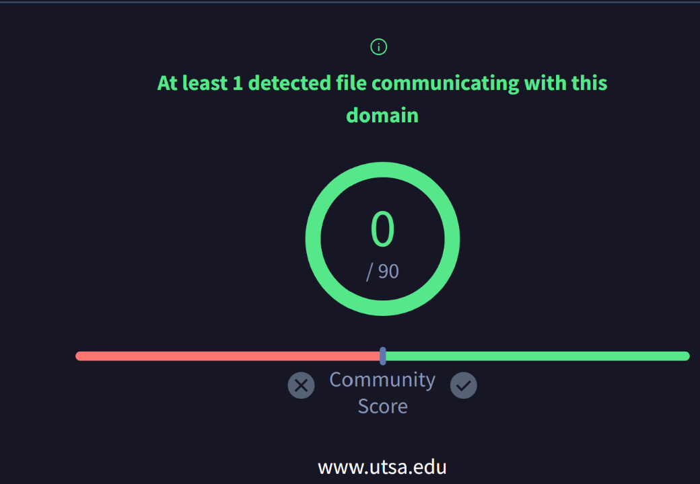

4b. 

4c. 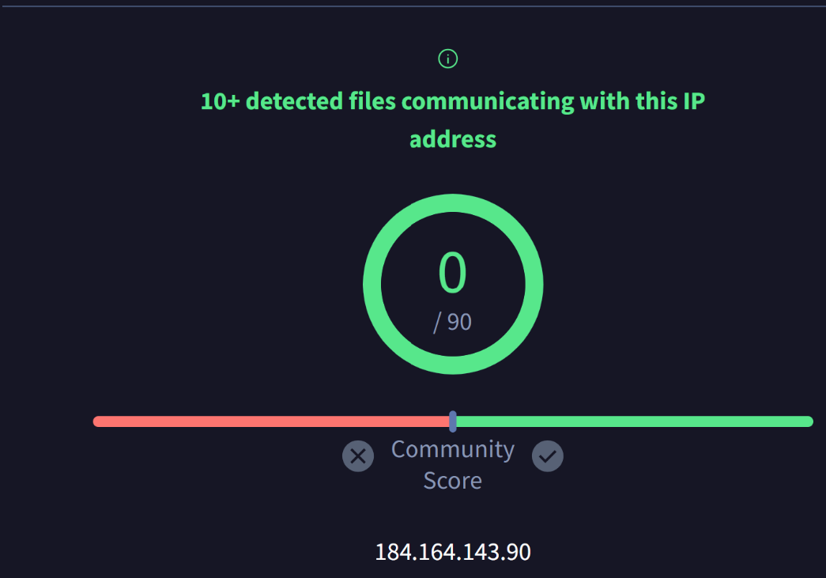

4d. 